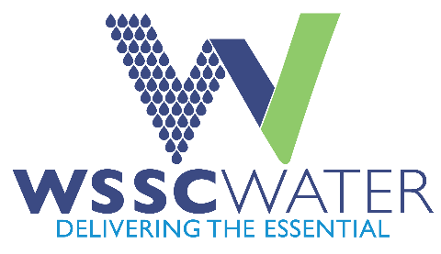

Western Branch water Resource Recovery Facility (WRRF) Potable Water System Upgrade
Upcoming Contract Outreach Event
April 30
Name | Company | Email
Eric Mouillesseaux | EBA Engineering | emouillesseaux@flippo.com
Rizwan Siddiqi | AsSabur Engineering | rizwan.siddiqi@ebaengineering.com
Ahmed Mohamed | Flippo Construction Company, Inc. | as.sabur.eng@comcast.net

